**Stimulus Fluctuations at Time Window = 200**

Original Model

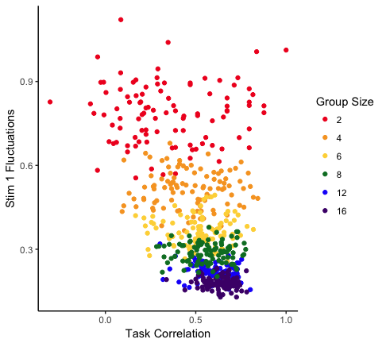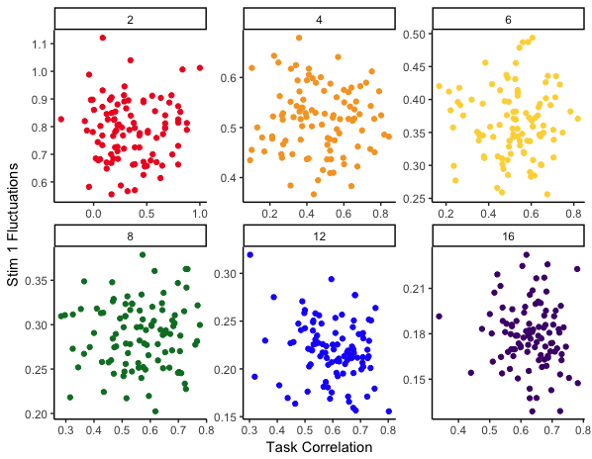

Density-Dependent Model

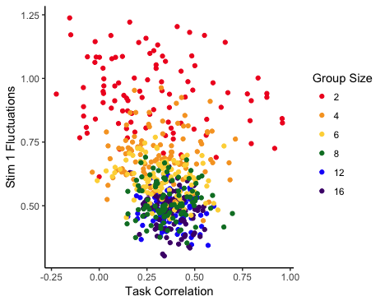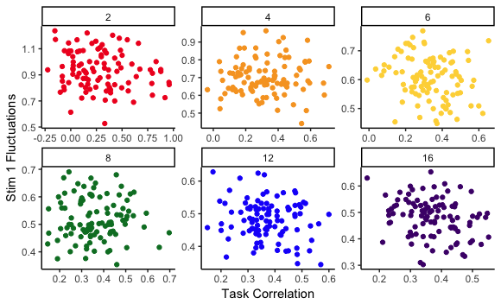

**Stimulus Fluctuations at Time Window = 1**

Original Model

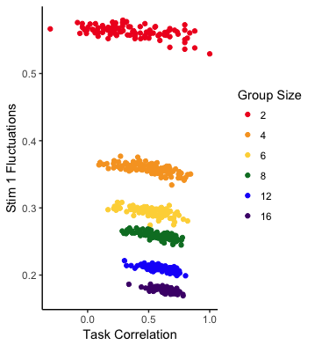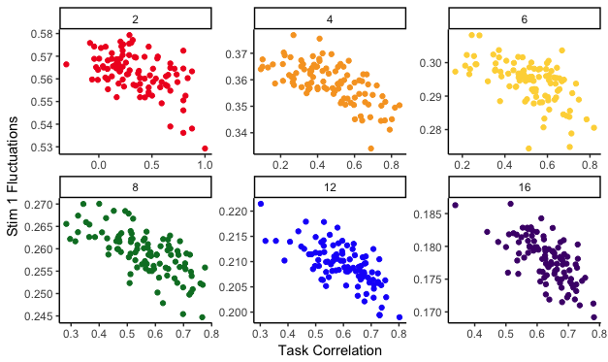

Density-Dependent Model

Remembering that stimulus demands () scales with group size (i.e., demand = ), we can show these stimulus fluctuations as either raw stimulus fluctuations or normalize for group size.

*Raw*

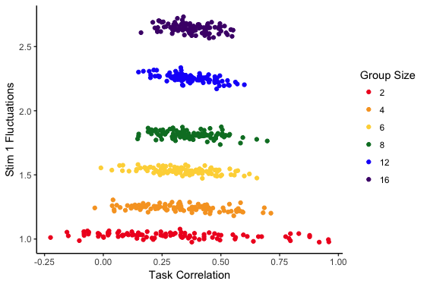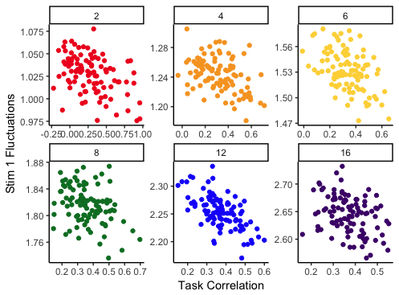

*Normalized*

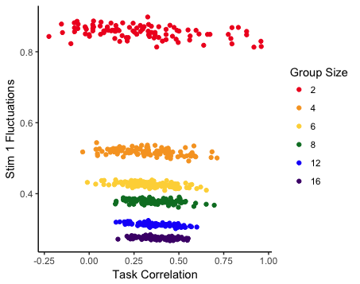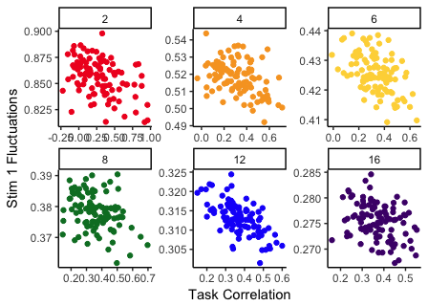

**Mean Stimulus Fluctuations and Task Fluctuations at time window 1**

Original Model

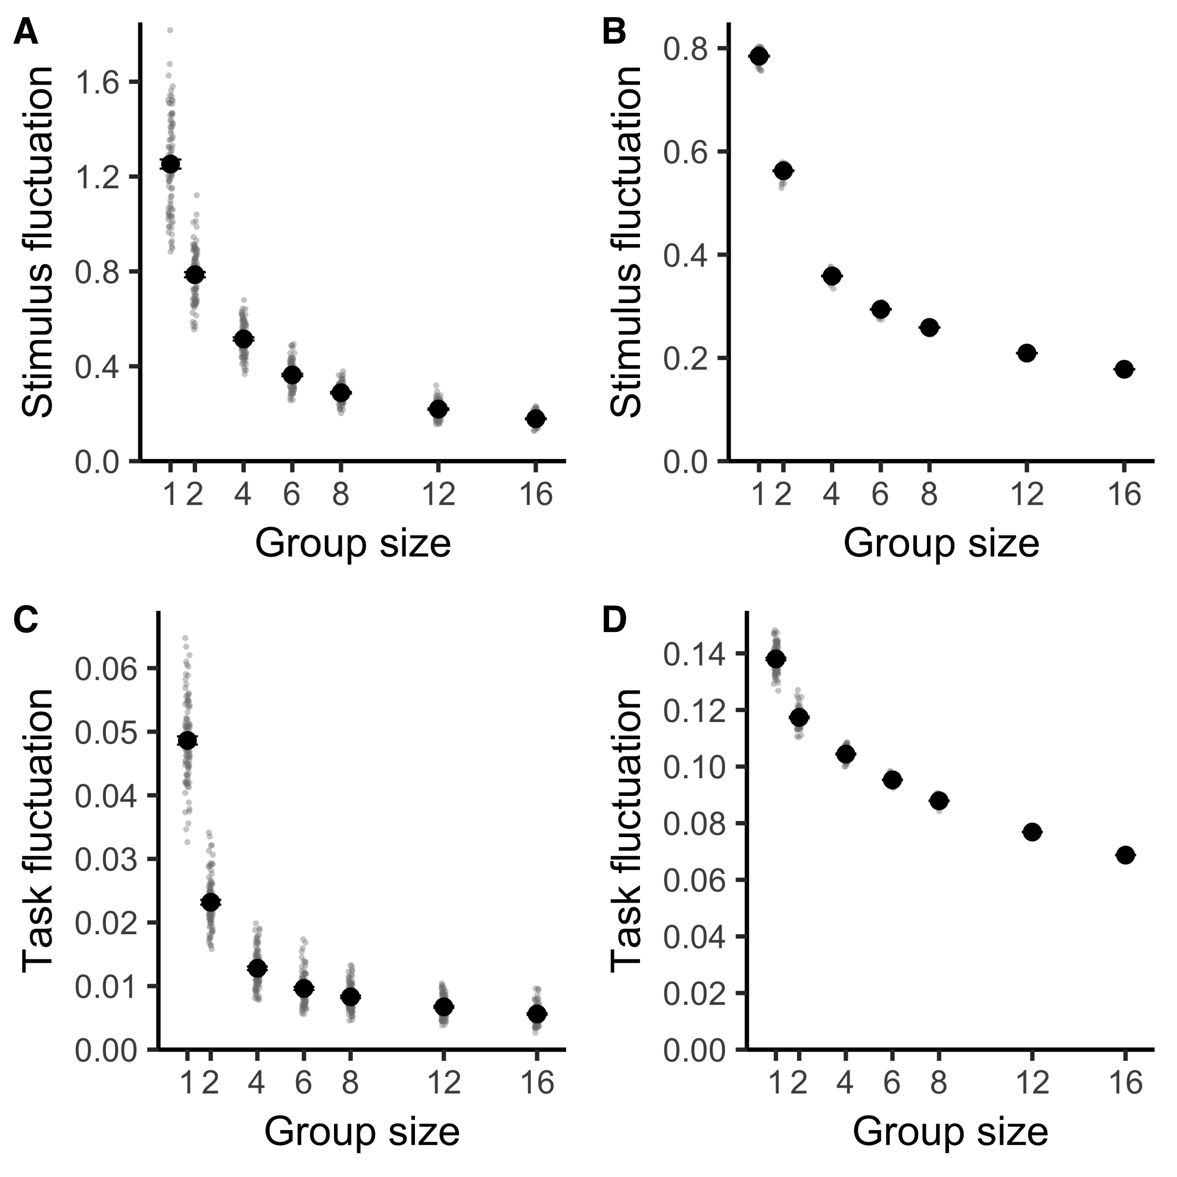

Density-Dependent Model

(*Raw*)

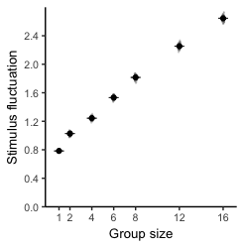

(*Normalized*)

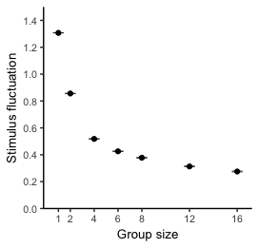

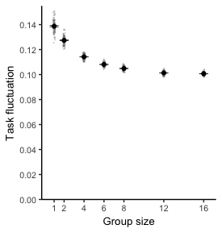

**Average Stimulus across entire simulation**

Original Model

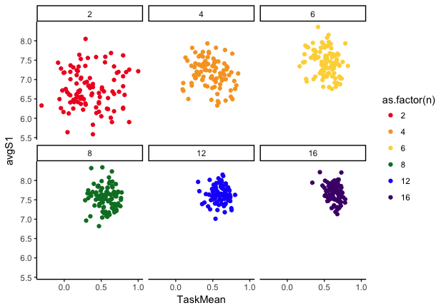

Density-Dependent Model

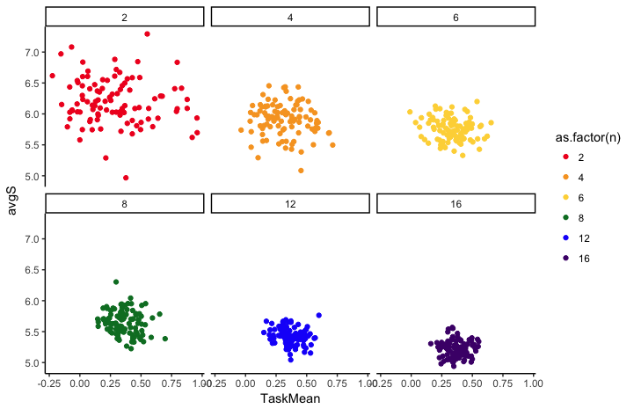

**Average Task performance across entire task simulation**

Original Model

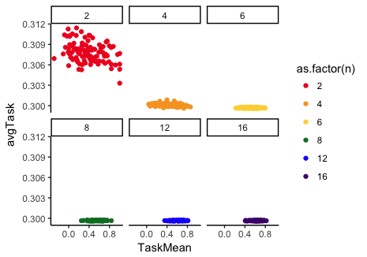

Density-Dependent Model

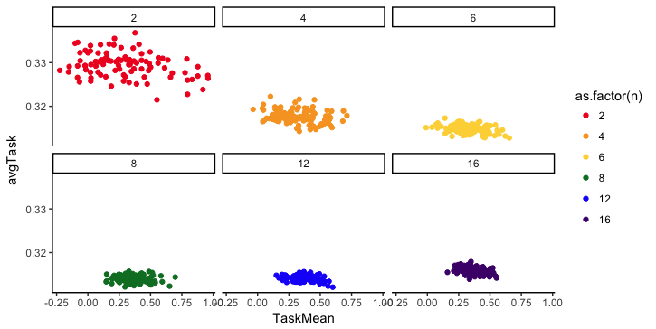

**Distribution of Task Performance**

The other plots aren’t included, but mean performance does drop but not near experimental values (could be due to being in suboptimal region of parameter space). Behavioral variance increases rapidly between group sizes 2 and 4 and levels off after that. Specialization is also largely linear and flat across group sizes.

